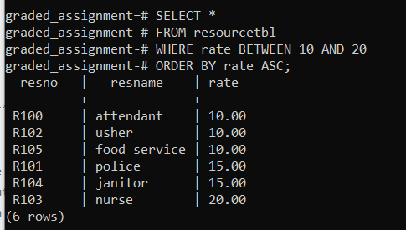

SELECT \*

FROM resourcetbl

WHERE rate BETWEEN 10 AND 20

ORDER BY rate ASC;